**Sponsored by**

**Wayne State University, Institute of Gerontology**

**Issues this Certificate of Attendance to**

________________________________________

**(First, Middle, Last Name, Credentials)**

**DATE**  October 30, 2024

**TITLE:** Navigating Difficult Conversations

**PROGRAM FORMAT Live Webinar**

|  |  |  |
| --- | --- | --- |
| **Credit Type** | **Credit or Contact Hours** | **Continuing Education Information** |
| MI Social Work | 1.5 | The IOG is an approved provider with the Michigan Social Work Continuing Education Collaborative. Approved provider #MICEC-0068. |
| National Association of SW | 1.5 | Approved by the National Association of Social Workers. Category Social Work  Approval # 886813915-6742 |
| CCM | 1.5 | Pre-approved by the Commission for Case Manager Certification to provide continuing education credit to CCM® board-certified case managers. Approved for 1.5 CE contact hour(s). Activity Code: I00059424 Approval #: 240001494 |
| Nursing | 1.5 | This nursing continuing professional development activity was approved by Louisiana State Nurses Association - Approver, an accredited approver by the American Nurses Credentialing Center’s Commission on Accreditation LSNA-100952394-2023 |
| General, OT & PT |  | Certified through the Institute of Gerontology, Wayne State University, as a continuing education program that meets requirements. |

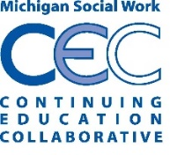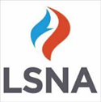 Peter Lichtenberg, PhD, IOG Director

**APPROVERS**