**Wayne State University, The Institute of Gerontology (IOG)**

**Issues this Certificate of Attendance to**

________________________________________

**DATE 10-31-2024**

**TITLE Managing Pain Therapeutically and Safely, 1.5 credits for Pain Requirement**

**PRESENTER Dana Rizzo, RN, BSN, ACM-RN**

**FORMAT Live Webinar**

|  |  |  |
| --- | --- | --- |
| **Credit Type** | **Credit or Contact Hours** | **Continuing Education Information** |
| MI Social Work | 1.5 | The IOG is an approved provider with the Michigan Social Work Continuing Education Collaborative. Approved provider #MICEC-0068. |
| National Association of Social Workers | 1.5 | Approved by the National Association of Social Workers. Category Social Work  Approval # 886813915-6829 |
| Nursing | 1.5 | This nursing continuing professional development activity was approved by Louisiana State  Nurses Association - Approver, an accredited approver by the American Nurses Credentialing  Center’s Commission on Accreditation. Activity number: LSNA-101056595-2023 |
| General, OT & PT | 1.5 | Certificates for General Education and therapies accredited through the IOG. |
| CCM | 1.5 | Pre-approved by the Commission for Case Manager Certification to provide continuing education credit to CCM® board-certified case managers. Approved for CE contact hour 1.5, Activity Code: Activity Code: S00060688 Approval #: 240002756 |

APPROVERS:

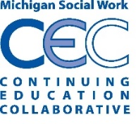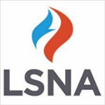 Peter Lichtenberg, PhD, IOG Director