**The Institute of Gerontology (IOG) at Wayne State University**

**Issues this Certificate of Attendance to**

________________________________________

**DATE**  March 6, 2025

**TITLE** "Behind Closed Doors: The Reality of Human Trafficking"

**PRESENTER** **Jennifer Mansfield, MA**

**FORMAT Live Webinar**

|  |  |  |
| --- | --- | --- |
| **Credit Type** | **Credit or Contact Hours** | **Continuing Education Information** |
| MI Social Work | 1.5 | The IOG is an approved provider with the Michigan Social Work Continuing Education Collaborative. Approved provider #MICEC-0068. |
| National Association of Social Workers | 1.5 | Approved by the National Association of Social Workers. Category Social Work  Approval # 886813915-4981 |
| Nursing | 1.5 | This nursing continuing professional development activity was approved by Louisiana State Nurses Association - Approver, an accredited approver by the American Nurses Credentialing Center’s Commission on Accreditation. LSNA-101077697-2024 |
| Case Manager | 1.5 | Pre-approved by the Commission for Case Manager Certification to provide continuing education credit to CCM® board-certified case managers. Approved for 1.5 CE contact hour(s). Activity Code: S00059081 Approval #: 240001151 |
| General, OT & PT | 1.5 | Certificates for General Education and therapies accredited through the IOG. |

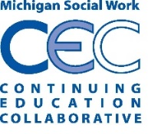

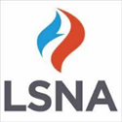

Peter Lichtenberg, PhD, IOG Director