**The Institute of Gerontology (IOG) at Wayne State University**

**Issues this Certificate of Attendance to**

________________________________________

**DATE 9-26-24**

**TITLE** Shining a Light on Depression and Anxiety:  Understanding, Coping and Healing

**PRESENTER Linda “Andi” Chapman, RN**

**FORMAT Live Webinar**

|  |  |  |
| --- | --- | --- |
| **Credit Type** | **Credit or Contact Hours** | **Continuing Education Information** |
| MI Social Work | 1.5 | The IOG is an approved provider with the Michigan Social Work Continuing Education Collaborative. Approved provider #MICEC-0068. |
| National Association of Social Workers | 1.5 | Approved by the National Association of Social Workers. Category Social Work .  Approval # 886813915-2065 |
| Nursing | 1.5 | This nursing continuing professional development activity was approved by Louisiana State Nurses Association - Approver, an accredited approver by the American Nurses Credentialing Center’s Commission on Accreditation. LNSA- 101077704-2024  LSNA-101077704-2024 |
| General, OT & PT | 1.5 | Certificate for General Education and therapies accredited through the IOG. |
| CCM | 1.5 | Pre-approved by the Commission for Case Manager Certification to provide continuing education credit to CCM® board-certified case managers. Approved for CE contact hour 1.5, Activity Code: S00059386 Approval #: 240001456 |

APPROVERS:

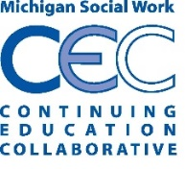

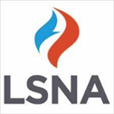 Peter Lichtenberg, PhD, IOG Director