**Sponsored by**

**Wayne State University, Institute of Gerontology**

**Issues this Certificate of Attendance to**

________________________________________

**(First, Middle, Last Name)**

**DATE**  Sept 24, 2024

**TITLE:** *The Essential Connection: Hydration and Well-Being****.***

**PRESENTER** **Dana Rizzo, RN, BSN, ACCM**

**PROGRAM FORMAT Live Webinar**

|  |  |  |
| --- | --- | --- |
| **Credit Type** | **Credit or Contact Hours** | **Continuing Education Information** |
| MI Social Work | 1.5 | The IOG is an approved provider with the Michigan Social Work Continuing Education Collaborative. Approved provider #MICEC-0068. |
| National Association of Social Workers | 1.5 | This program is approved by the National Association of Social Workers (Approval  886813915-1852) for (1.5) continuing education contact hours. Category: social work |
| Nursing | 1.5 | This nursing continuing professional development activity was approved by Louisiana State Nurses Association - Approver, an accredited approver by the American Nurses Credentialing Center’s Commission on Accreditation. LSNA-101077738-2024 |
| Case Manager | 1.5 | Pre-approved by the Commission for Case Manager Certification to provide continuing education credit to CCM® board-certified case managers. Approved for 1.5 CE contact hour(s). Activity Code: I00060811, Approval #: 240002879 |
| General, OT & PT | 1.5 | Certificates for General Education and therapies accredited through the IOG. |

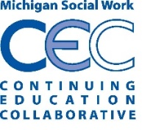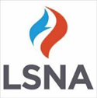 Peter Lichtenberg, PhD, IOG Director

**APPROVERS**