**­­­The Institute of Gerontology (IOG) at Wayne State University**

**Issues this Certificate of Attendance to**

________________________________________

**DATE 4-29-2024**

**TITLE** Issues in Aging 2024: Navigating the Issues and Challenges in Aging

**FORMAT** Live in Person

|  |  |  |
| --- | --- | --- |
| **Credit Type** | **Credit or Contact Hours** | **Continuing Education Information** |
| MI Social Work | 6 | The IOG is an approved provider with the Michigan Social Work Continuing Education Collaborative. Approved provider #MICEC-0068. |
| Nursing | 6 | This nursing continuing professional development activity was approved by Louisiana State Nurses Association - Approver, an accredited approver by the American Nurses Credentialing Center’s Commission on Accreditation. LSNA-101077694-2024 |
| CCM | 6 | This program has been pre-approved by The Commission for Case Manager Certification to provide continuing education credit to CCM® board-certified case managers. The course is approved for 6 CE contact hour(s). Activity Code: S00059075 Approval #: 240001145    To claim these CEs, log into your CCMC Dashboard at www.ccmcertification.org |
| General, OT & PT | 6 | Certificates for General Education, service coordinators, and therapies accredited through the IOG. |

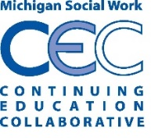

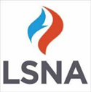

Peter Lichtenberg, PhD, IOG Director